Jing Si Multipurpose Folding Platform

The development of this product began in the summer of 2010 during the devastating floods in Pakistan.

The “Jing Si Multipurpose Folding Platform” can be configured to be a single bed, as well as a bench. The entire platform folds from a single piece, with no assembly required, making it easy to transport and to store.

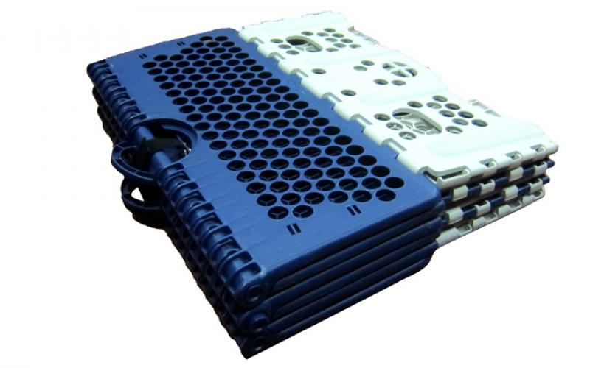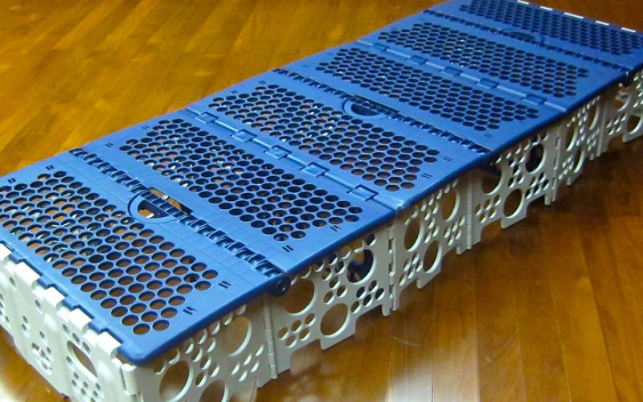
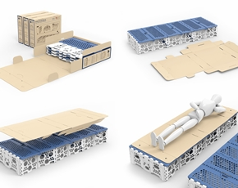
The primary goal of this foldable platform is to be able to raise the occupant off the ground, so that they don't have to sleep on the ground anymore. In addition, its sides are hollow and allows for improved portability and ventilation. The platform is also made with a special food-grade plastic (Polypropylene or PP) to ensure that it would not irritate even a baby’s skin. Whether in the sitting or the sleeping configuration, this versatile platform will be a comfortable and safe place to rest.

